AWS Site-to-Site VPN
A Site-to-Site VPN is a secure, encrypted network connection that links two separate networks (often in different physical locations) over the internet.
It allows them to communicate as if they were part of the same private network.
Instead of connecting device-to-network (like a client VPN), a Site-to-Site VPN connects network-to-network.

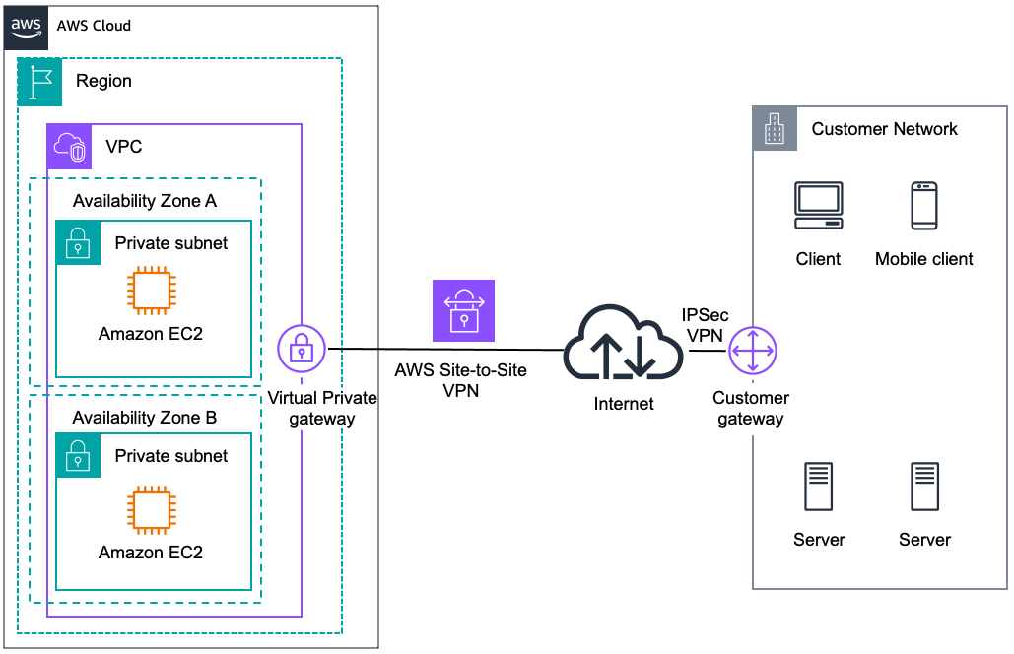
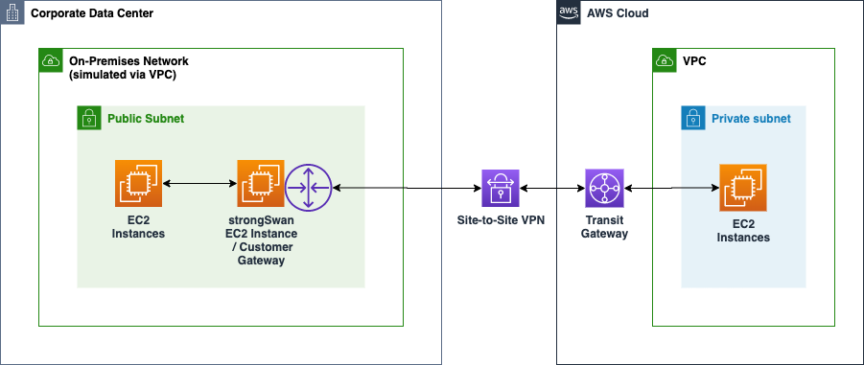

How it Works
- Both sites (networks) have VPN gateways (could be a router, firewall, or AWS VPN gateway).
- These gateways establish an IPSec-encrypted tunnel over the public internet.
- Once the tunnel is active, resources in Site A can directly communicate with resources in Site B over private IP addresses, securely.

Why We Use It
- Secure communication between offices or datacenters
  - Encrypts all traffic between sites to prevent eavesdropping.
- Extend private networks
  - Treats remote offices as part of the same internal LAN.
- AWS Hybrid Networking
  - Connect on-premises infrastructure to AWS VPC securely.
- Cost-effective alternative to dedicated lines
  - Cheaper than leased lines like MPLS, yet still secure.
- Business continuity
  - Keep apps and databases synchronized across locations.

Scenario Example
Company ABC has:
- Headquarters in Mumbai (with on-premises servers and databases).
- Branch office in Delhi.
They want employees in Delhi to access the same internal ERP system and file servers as those in Mumbai, without exposing them to the internet.
Solution:
- Install VPN-capable routers at both locations.
- Configure an IPSec Site-to-Site VPN between Mumbai and Delhi over their internet connections.
- Once connected:
  - Users in Delhi access the ERP server in Mumbai using private IP addresses.
  - Data is encrypted between sites, protecting sensitive company information.
  - From the user’s perspective, both locations are part of one big internal network.

💡 In AWS terms:
If you have workloads in AWS VPC and you need to securely connect to your on-premises network, you can set up an AWS Site-to-Site VPN between your AWS Virtual Private Gateway (VGW) and your on-premises VPN device.

